**Using Triplet Loss for Face Recognition Systems**

Face recognition systems have become increasingly integral in modern technologies, from smartphone authentication to surveillance systems. Developing an effective face recognition model requires not just high accuracy but also the ability to generalize well to unseen data. A pivotal approach to achieving this is through metric learning, specifically leveraging **Triplet Loss**.

### What is Triplet Loss?

Triplet Loss is a loss function designed to ensure that embeddings of similar inputs (e.g., images of the same person) are closer together in the feature space, while embeddings of dissimilar inputs (e.g., images of different people) are further apart. It operates on triplets of samples, each consisting of:

1. **Anchor (A):** A sample image for which the embedding will be generated.
2. **Positive (P):** A sample image of the same class as the anchor.
3. **Negative (N):** A sample image of a different class.

The goal is to ensure the distance between the anchor and the positive is smaller than the distance between the anchor and the negative by a margin α. This relationship can be expressed mathematically:

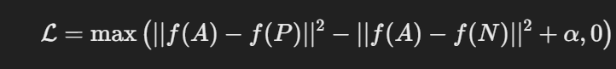

Where:

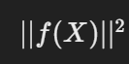 represents the squared Euclidean distance between embeddings.

α is a margin that ensures the separation between classes.

f is an embedding

### Why Use Triplet Loss for Face Recognition?

1. **Fine-Grained Differentiation:** Face recognition involves distinguishing subtle differences between faces. Triplet Loss trains models to focus on these nuances by directly optimizing the relative distances between embeddings.
2. **Generalization to Unseen Classes:** Unlike classification-based methods, which predict a fixed number of classes, Triplet Loss learns a discriminative feature space. This enables the model to generalize to individuals not seen during training.
3. **Compact Representations:** Embeddings produced using Triplet Loss are often compact and suitable for tasks like clustering and retrieval.

### Building a Face Recognition System with Triplet Loss

Here’s an outline of the key steps:

#### 1. ****Dataset Preparation****

* **Face Detection and Alignment:** Ensure all face images are cropped and aligned consistently, typically using algorithms like Haar cascades.
* **Triplet Sampling:** Construct triplets (anchor, positive, negative) from the dataset. This is crucial for effective training. Strategies include:
  + **Hard Triplet Mining:** Select the hardest positives (closest to the anchor) and hardest negatives (closest to the positive).
  + **Semi-Hard Mining:** Choose negatives closer to the anchor than the positive but still beyond the margin.

#### 2. ****Model Architecture****

A common architecture for embedding generation is a **Convolutional Neural Network (CNN)**. Notable examples include:

* **Siamese Networks:** A network trained with pairwise inputs.
* **FaceNet:** A CNN explicitly designed to learn embeddings using Triplet Loss.

The final layer of the network outputs a fixed-length embedding vector, normalized to have a unit norm for consistent distance computation.

#### 3. ****Training****

* **Optimizer:** Adam or SGD with a carefully tuned learning rate.
* **Loss Function:** Implement the Triplet Loss function, ensuring gradient stability.
* **Regularization:** Techniques like dropout and batch normalization can prevent overfitting.

#### 4. ****Inference****

At inference, the system computes embeddings for input images and compares them using a distance metric, typically cosine similarity or Euclidean distance. A threshold is set to classify whether two images belong to the same person.

### Challenges and Considerations

1. **Efficient Triplet Selection:** Poorly chosen triplets can lead to slow convergence. Mining techniques are essential but computationally expensive.
2. **Margin Selection:** The choice of margin α\alpha significantly affects performance. A small margin might not create enough separation, while a large margin could lead to optimization difficulties.
3. **Scalability:** Large datasets can make triplet mining and training computationally prohibitive. Techniques like online triplet mining and mini-batch processing are often necessary.

### Advantages Over Other Loss Functions

While alternatives like **Softmax Loss** are suitable for classification tasks, they are less effective for open-set problems like face recognition. Triplet Loss allows models to excel in scenarios where they need to compare unseen identities rather than classify among predefined ones.

### Real-World Applications

1. **Access Control:** Smartphones and smart home devices use face recognition for secure and convenient authentication.
2. **Surveillance Systems:** Identifying individuals in public spaces based on pre-enrolled facial data.
3. **Photo Organization:** Clustering photos in personal collections based on the identities of people in the images.

**BioFace:**

In Endless data we have used the triplet loss to train our neural network for embedding face information in a float vector of 256 floats. Then we used this network in android application.   
The figure below shows a snapshot of the users interface of our application where you can see that we have defined two users, John and Nicolas.

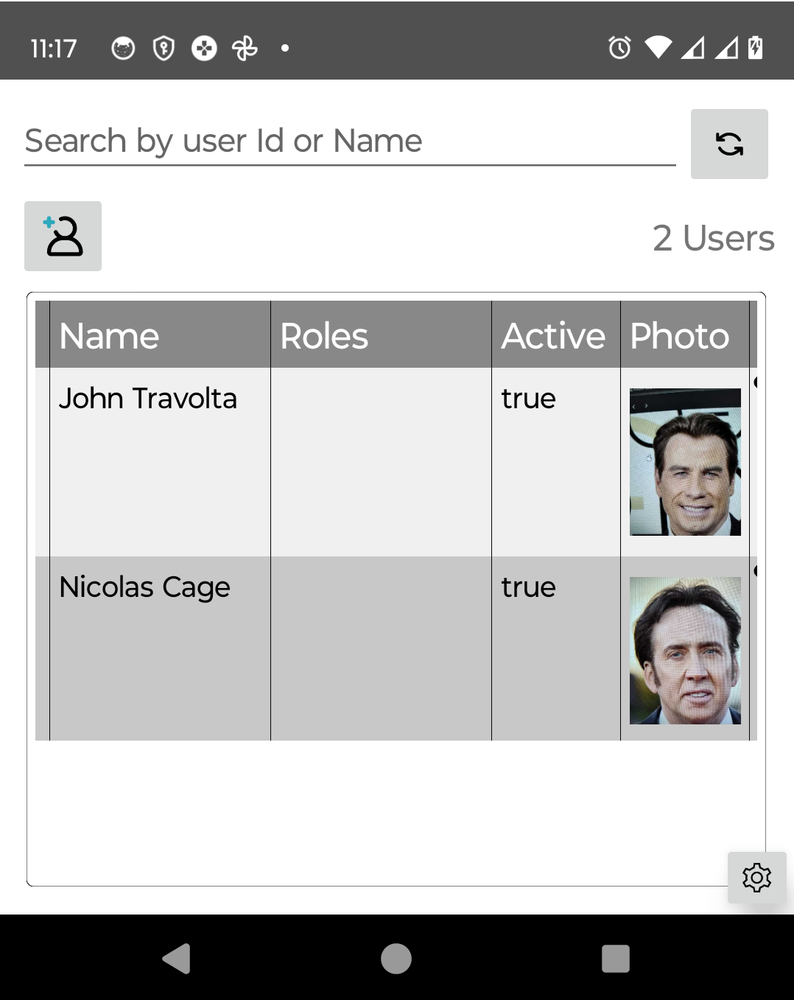

Our application first detect the face in the image and if the image is live or being replied. In the figure below, the left image shows the detected face rectangle with yellow and the co-centered red circles at the top right corner indicates that the detected face is not live, since this photo is displayed at the screen and unfortunately we did not get to meet John Travlota and test the application with him :).

The screenshot to the right shows more information inside the detected box this information is about the orientation of the face with respect to the camera which is also very important parameters for the face recognition algorithm since faces which are rotated in large angles will have embedding which are far from the registered image.

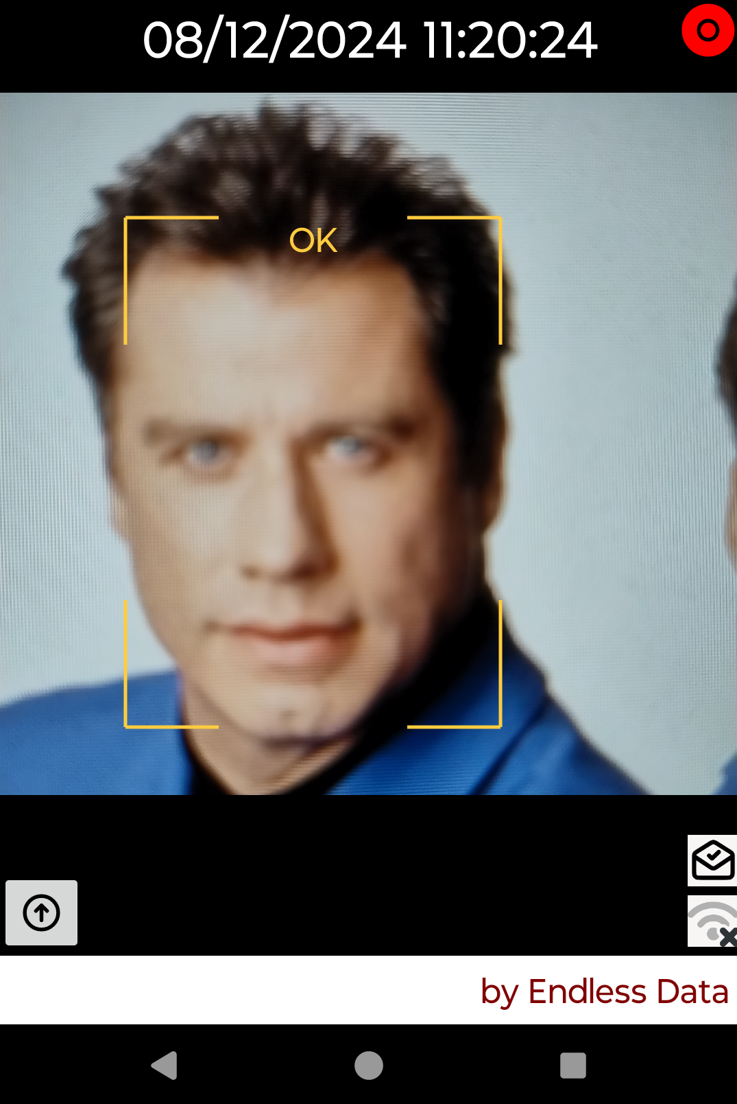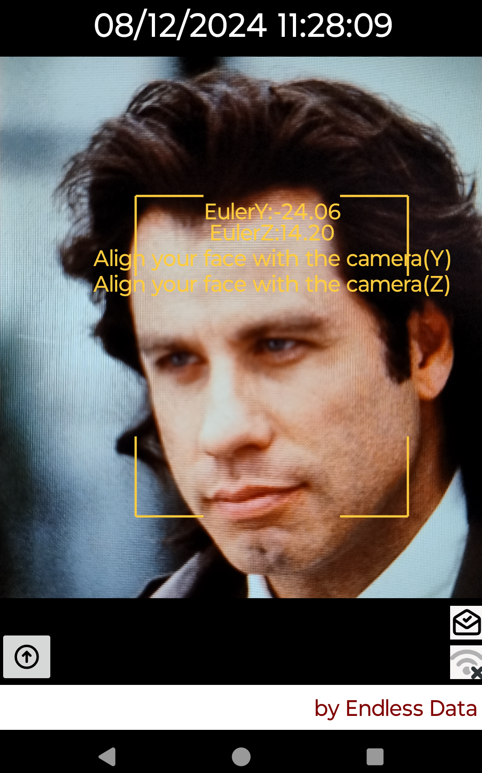

The above two steps (liveness and face detection) are very important and you will not be able to have a face recognition system without them. However the neural networks which achieve these two tasks are trained using loss function other than triplet loss. So lets us check the performance of the embedding neural network which is trained using the triplet loss. First we disable live detection since we will be using photos and not real persons.

In the figure below you see on the left, you see the image which we are putting infront of the camer, note that it is different than the registered image and that is important because we want to show that the neural network which is trained using the triplet loss is able to produce similar embedding to the same user even if he has different cloth, different hair, and even different age. On the screenshot at the right shows that the application was able to match the embedding for the photo to the left with the registered image and displays the information of the registered users.

[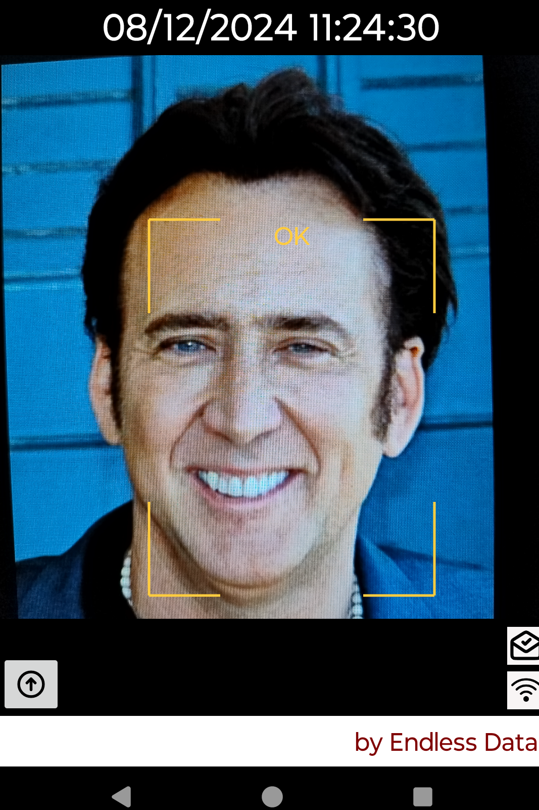](https://www.edatame.com/)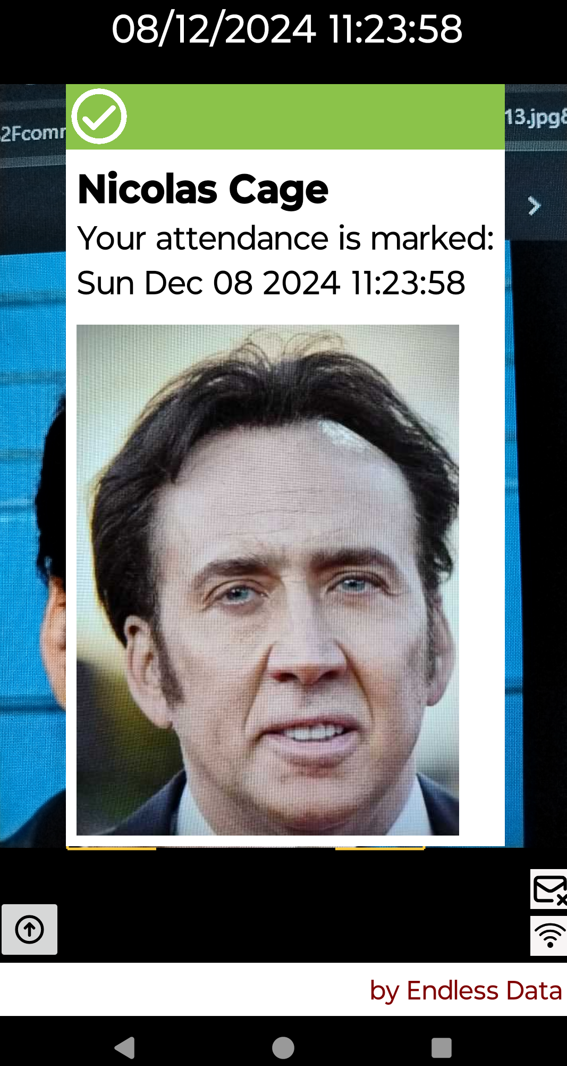

Now let us see what woould happen if we make up a face where half of the face is from John and half from Nicolas. In the figure below you can see the input image in the left screenshot. Note that face detection network detect the correct position of the face. However on the right you can see that the application is not able to recognize the face and it suggests that this is a new user. Of course the embedding neural network is not trained for such cases and the outputed embeddings are derived from both halves of the photo so they will be much different from the two registered users. By the way, the photos are taken from the film face-off which is another case where the triplet loss will fail to tell you that the actors have changed their faces.

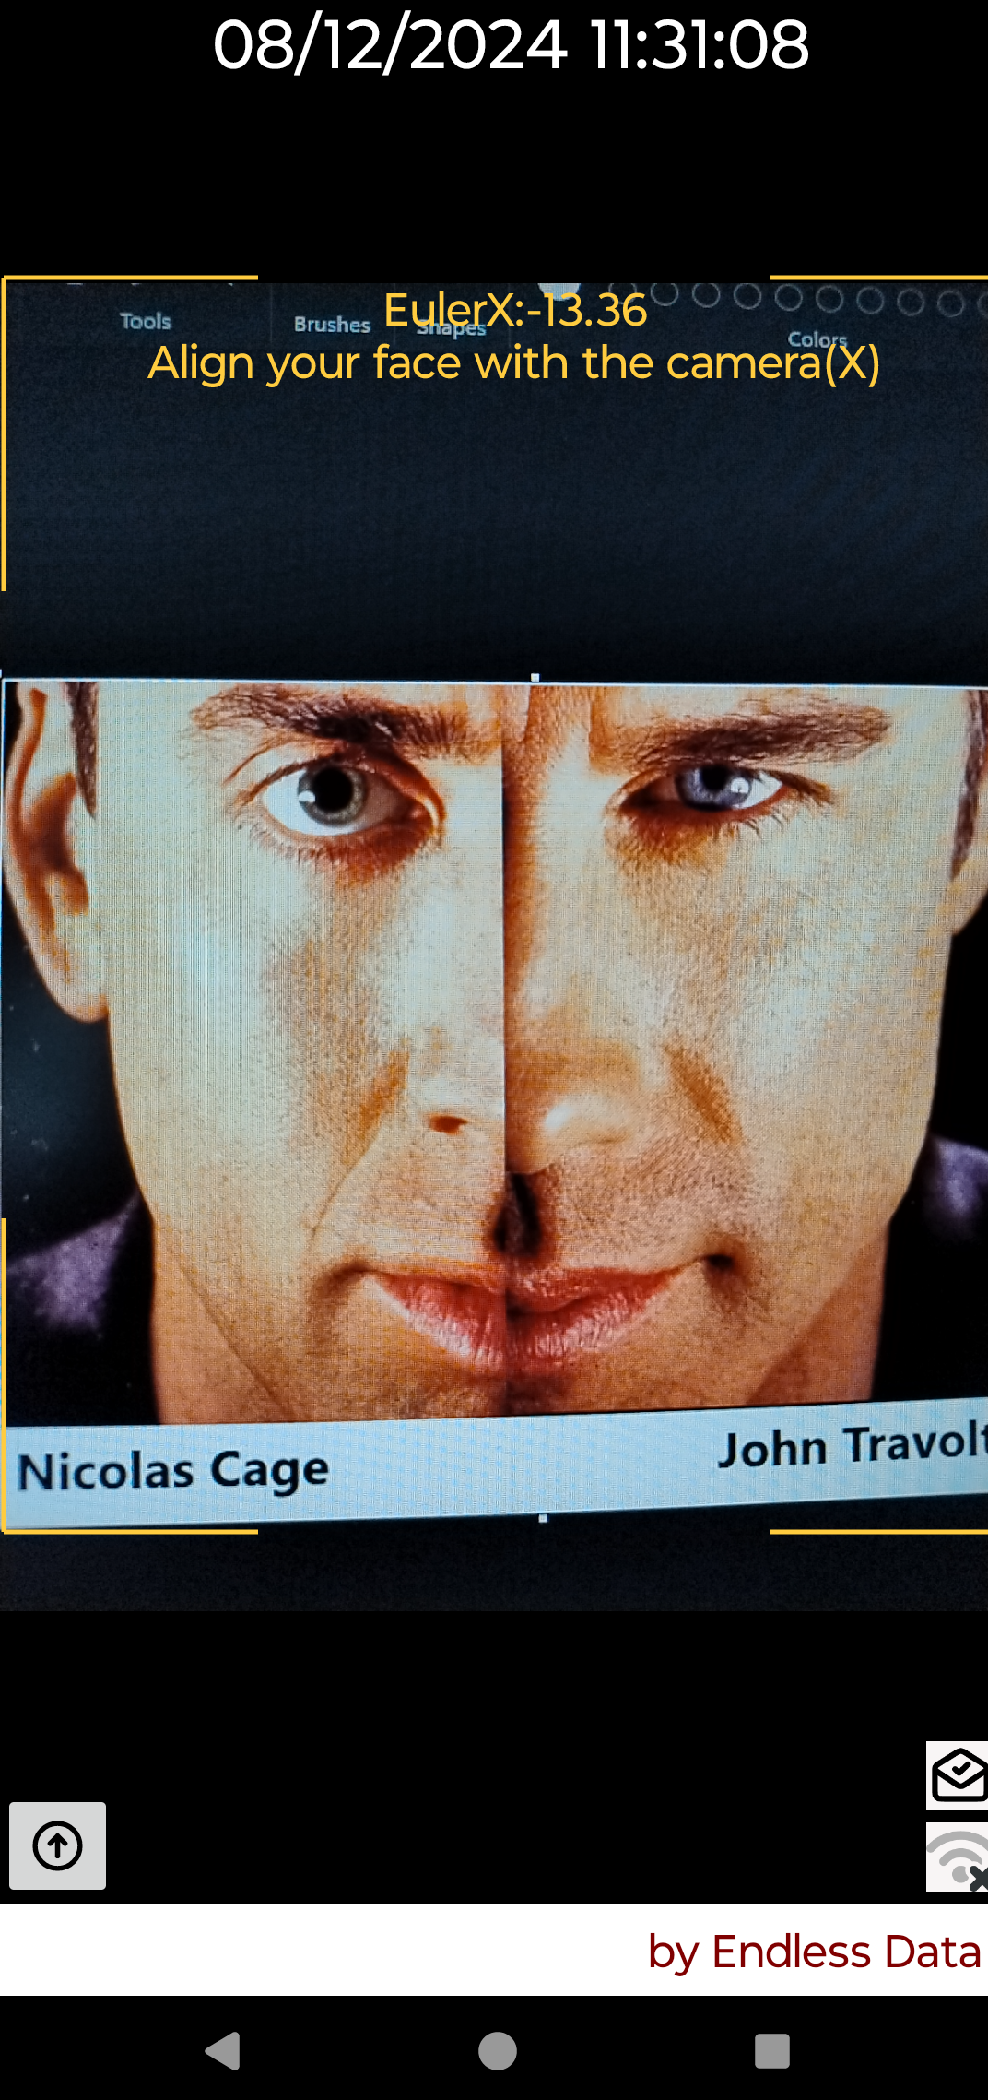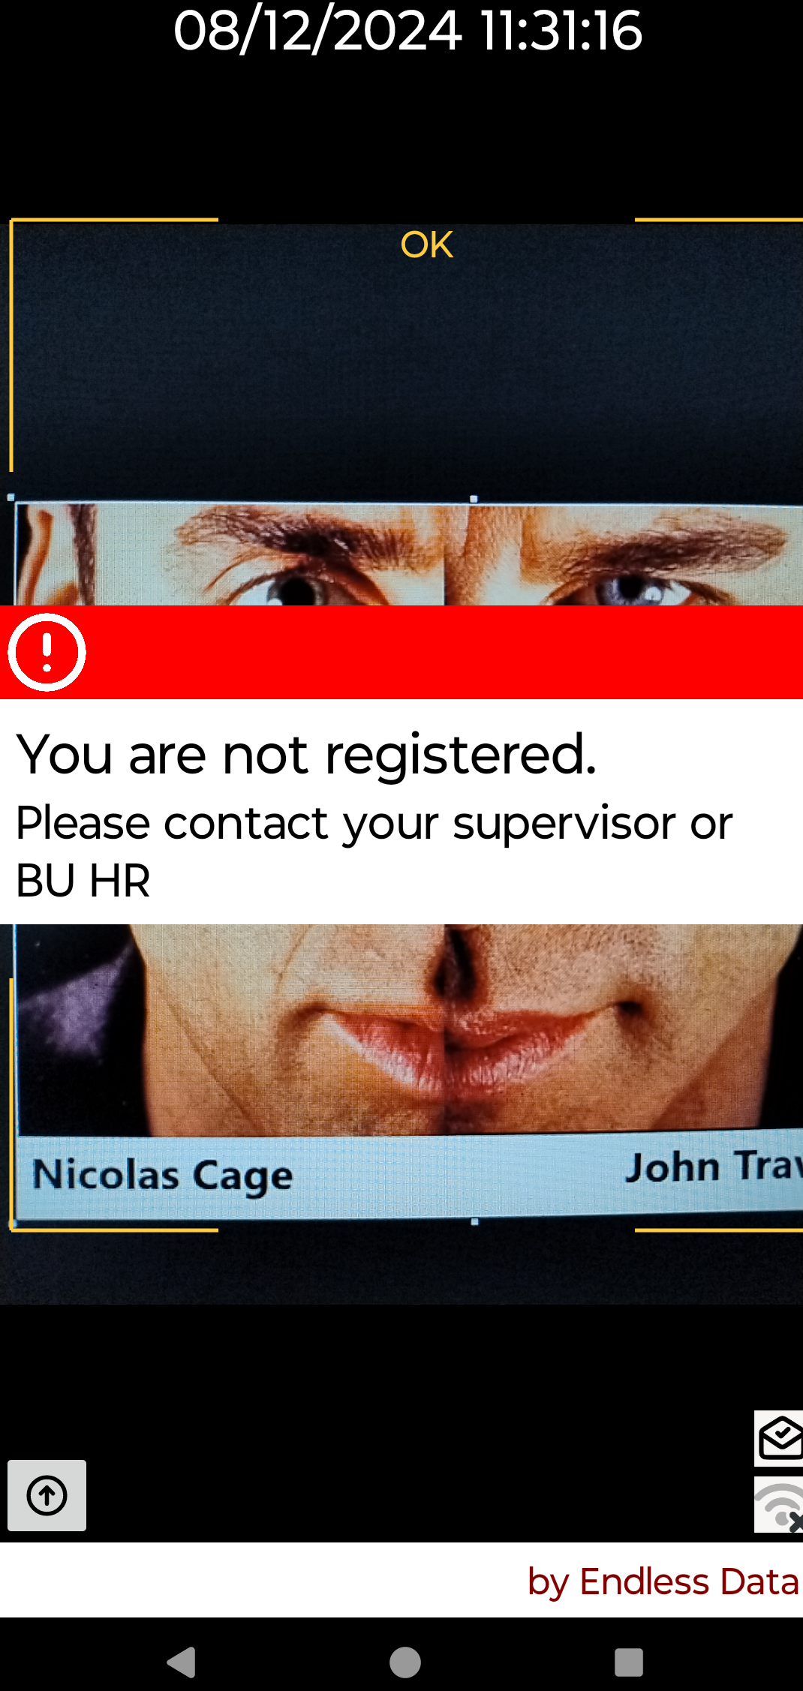

### Conclusion

Triplet Loss is a cornerstone of modern face recognition systems. By focusing on relative distances between embeddings, it enables robust and generalizable models. While challenges like triplet selection and computational demands remain, advancements in model architectures and optimization strategies continue to refine its effectiveness. Whether integrated into mobile devices or large-scale surveillance networks, Triplet Loss proves indispensable in building intelligent and reliable face recognition systems.

**Reference**

The concept of Triplet Loss was first introduced in the paper **"FaceNet: A Unified Embedding for Face Recognition and Clustering"** by Florian Schroff, Dmitry Kalenichenko, and James Philbin, presented at the 2015 IEEE Conference on Computer Vision and Pattern Recognition (CVPR).

Here’s the full reference:

Schroff, F., Kalenichenko, D., & Philbin, J. (2015). **FaceNet: A Unified Embedding for Face Recognition and Clustering.** Proceedings of the IEEE Conference on Computer Vision and Pattern Recognition (CVPR), 2015, pp. 815-823.

Testing software available in [faceDetection](https://zkteco-dubai.com)

This seminal paper describes the design and use of Triplet Loss in detail and its application in the FaceNet model, which demonstrated state-of-the-art performance in face recognition and clustering tasks at the time.